EXPERIMENT :5

Aim
To simulate and analyze a microwave directional coupler and two-way power divider using MATLAB and characterize their performance using S-parameters.

Objectives
- To study the working principles of directional couplers and two-way power dividers.
- To calculate and analyze S-parameters such as S11, S21, S12, S22, S31, and S41.
- To evaluate reflection, transmission, coupling, and isolation characteristics.
- To plot and compare the S-parameter responses over the operating frequency range.
Program code:
clc; clear; close all;
f=linspace(8e9,12e9,201); f0=10e9;
C=10; Z0=50;
S21=10^(-1.5/20)*ones(size(f));
S31=10^(-C/20)*exp(-((f-f0)/2e9).^2);
S41=10^(-25/20)*ones(size(f));
S11=10^(-20/20)*ones(size(f));
I=-20*log10(abs(S41));
Cp=-20*log10(abs(S31));
IL=-20*log10(abs(S21));
D=I-Cp;

S21d=ones(size(f))/sqrt(2);
S31d=ones(size(f))/sqrt(2);
P1=abs(S21d).^2*100;
P2=abs(S31d).^2*100;

fprintf('Coupling = %.2f dB\n',Cp(101));
fprintf('Isolation = %.2f dB\n',I(101));
fprintf('Insertion Loss = %.2f dB\n',IL(101));
fprintf('Directivity = %.2f dB\n',D(101));
fprintf('Divider output powers = %.1f%%, %.1f%%\n',...
P1(101),P2(101));

figure('Color','w','Position',[100 100 1000 650]);
subplot(2,2,1);
plot(f/1e9,20*log10(abs(S11)),'k',...
f/1e9,20*log10(abs(S21)),'b',...
f/1e9,20*log10(abs(S31)),'r',...
f/1e9,20*log10(abs(S41)),'g','LineWidth',1.5);
grid on; xlabel('Frequency (GHz)'); ylabel('Magnitude (dB)');
title('Directional Coupler S-Parameters');
legend('S11','S21','S31','S41');

subplot(2,2,2);
plot(f/1e9,Cp,'r',f/1e9,I,'b',...
f/1e9,D,'k','LineWidth',1.5);
grid on; xlabel('Frequency (GHz)'); ylabel('dB');
title('Coupling, Isolation and Directivity');
legend('Coupling','Isolation','Directivity');

subplot(2,2,3);
plot(f/1e9,IL,'b','LineWidth',1.5);
grid on; xlabel('Frequency (GHz)'); ylabel('IL (dB)');
title('Insertion Loss');

subplot(2,2,4);
plot(f/1e9,P1,'b',f/1e9,P2,'r','LineWidth',1.5);
grid on; xlabel('Frequency (GHz)'); ylabel('Power (%)');
title('Two-Way Power Divider');
legend('Output 1','Output 2');
title('Microwave Coupler and Power Divider Analysis');
Output:
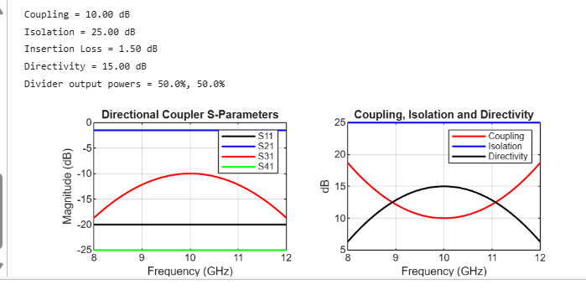
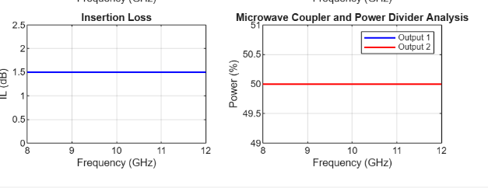
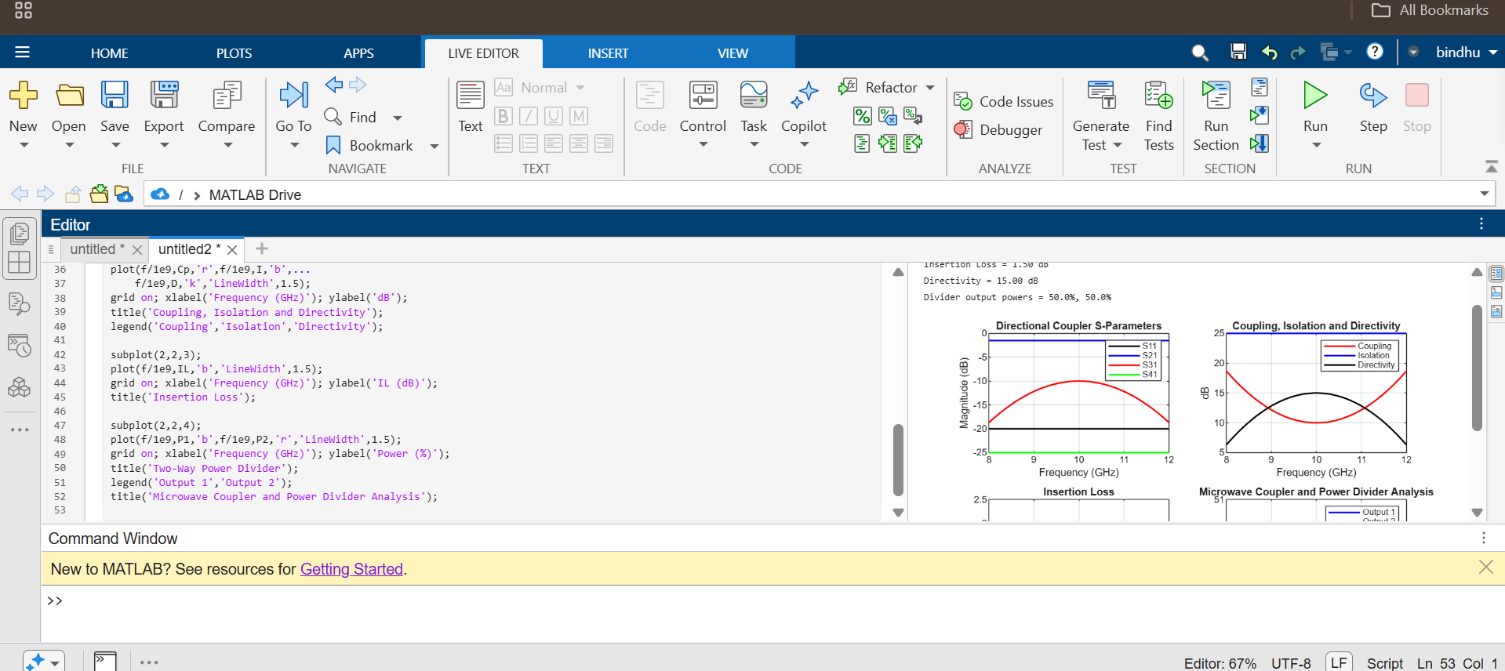
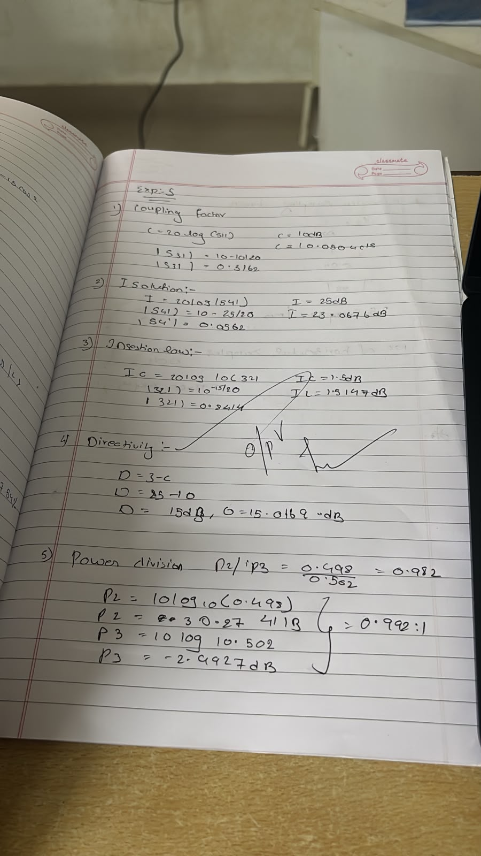

Result
The microwave directional coupler and two-way power divider were successfully simulated using MATLAB, and their S-parameters were analyzed to evaluate reflection, transmission, coupling, and isolation characteristics.

